KYE 23.09.2025
Starter –
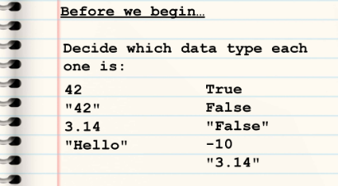
Integer Boolean
String Boolean
Float Integer
String String
Comparison table:
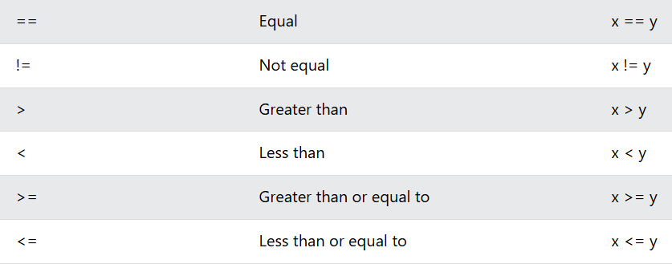
Using the 4 different data types:
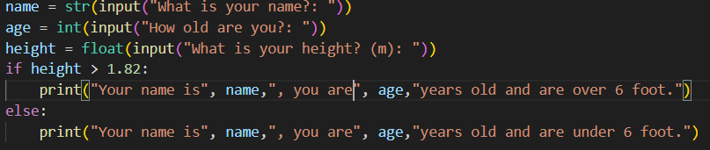
Real-world scenarios:
